# Heroku Install

## Steps

### Signup Heroku

<https://signup.heroku.com/>



### Download and install

Prerequisites

Git Install

<https://git-scm.com/book/en/v2/Getting-Started-Installing-Git>

First-time GIT setup

<https://git-scm.com/book/en/v2/Getting-Started-First-Time-Git-Setup>

brew tap heroku/brew && brew install heroku

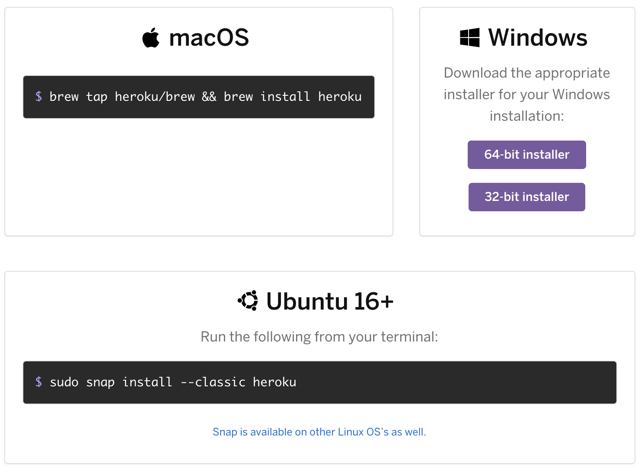

NPM install

npm install -g heroku

### Login

heroku login





Rohits-MacBook-Pro:flow-demo rohitbhardwaj$ heroku login

heroku: Press any key to open up the browser to login or q to exit:

Opening browser to https://cli-auth.heroku.com/auth/cli/browser/bde6eb81-227f-4615-8710-18d248700177

Logging in... done

Logged in as rohitbh@gmail.com

Rohits-MacBook-Pro:flow-demo rohitbhardwaj$

-- Without browser

heroku login -i

### Create App

Rohits-MacBook-Pro:git rohitbhardwaj$ **mkdir mynfjsapp**

Rohits-MacBook-Pro:git rohitbhardwaj$ **cd mynfjsapp/**

Rohits-MacBook-Pro:mynfjsapp rohitbhardwaj$ **heroku create**

Creating app... done, ⬢ stormy-eyrie-69056

https://stormy-eyrie-69056.herokuapp.com/ | https://git.heroku.com/stormy-eyrie-69056.git

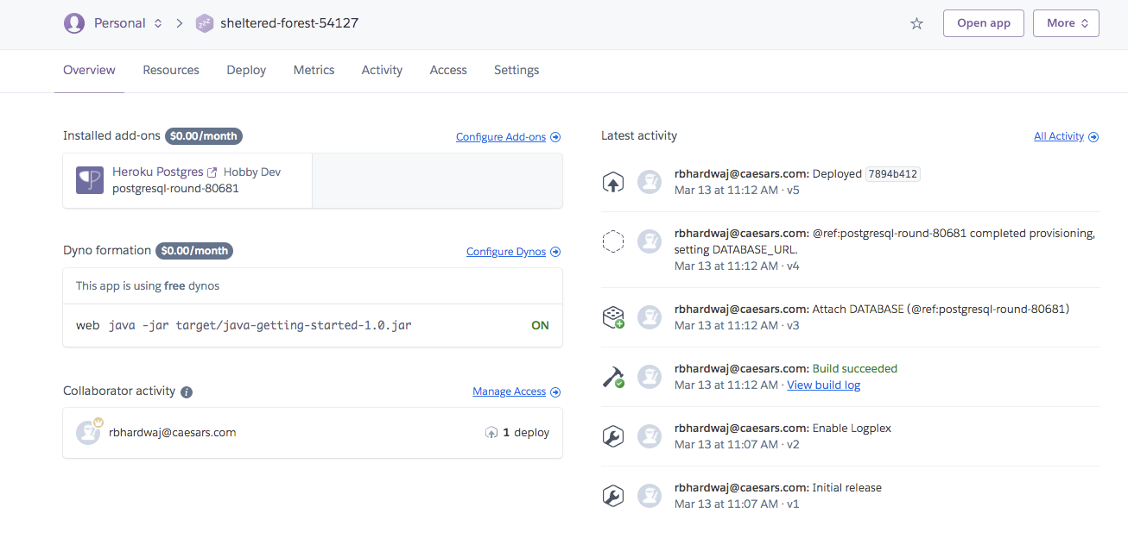

### References

<https://devcenter.heroku.com/articles/heroku-cli>